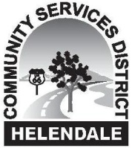
HELENDALE COMMUNITY SERVICES DISTRICT
SPECIAL Park & Recreation Committee
MEETING AGENDA

LOCATION: 26540 Vista Rd., Ste. C
August 21, 2018 at 3:00 P.M. Helendale, California 92342

- Approval of Agenda

- Accept Meeting Summary from the Park & Recreation Committee Meeting of July 10, 2018

- Public Participation

- Program Report
  - Update on Concerts in the Park
  - Update on Dog Park
  - Upcoming Activities
  - Seminars
  - Exercise Programs
  - Park Maintenance

- Discussion Regarding Park Restrooms

- Discussion Regarding Fitness Circuit

- Discussion Regarding Volleyball Project

- Discussion Regarding Turf at Park

- Comments/Discussion Items for Next or Future Agendas

- Adjournment

Pursuant to Government Code Section 54954.2(a), any request for a disability-related modification or accommodation, including auxiliary aids or services, that is sought in order to participate in the above agendized public meeting should be directed to the District’s General Manager’s office at (760) 951-0006 at least 24 hours prior to said meeting. The regular session of the Board meeting will be recorded. Recordings of the Board meetings are kept for the Clerk of the Board's convenience. These recordings are not the official minutes of the Board meetings.

